INDIA GENERAL ELECTIONS RESULT ANALYSIS 2024
Total Seats
SELECT
DISTINCT COUNT (Parliament_Constituency) AS Total_Seats
FROM constituencywise_results
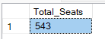

1.What is the total number of seats available for elections in each state
SELECT
s.State AS State_Name,
COUNT(cr.Constituency_ID) AS Total_Seats_Available
FROM
constituencywise_results cr
JOIN
statewise_results sr ON cr.Parliament_Constituency = sr.Parliament_Constituency
JOIN
states s ON sr.State_ID = s.State_ID
GROUP BY
s.State
ORDER BY
s.State;

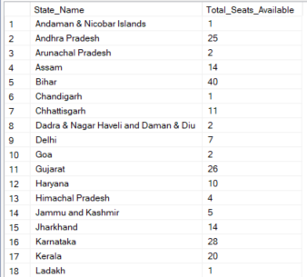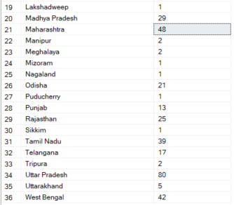
Total Seats Won by NDA Allianz
SELECT
SUM(CASE
WHEN party IN (
'Bharatiya Janata Party - BJP',
'Telugu Desam - TDP',
'Janata Dal (United) - JD(U)',
'Shiv Sena - SHS',
'AJSU Party - AJSUP',
'Apna Dal (Soneylal) - ADAL',
'Asom Gana Parishad - AGP',
'Hindustani Awam Morcha (Secular) - HAMS',
'Janasena Party - JnP',
'Janata Dal (Secular) - JD(S)',
'Lok Janshakti Party(Ram Vilas) - LJPRV',
'Nationalist Congress Party - NCP',
'Rashtriya Lok Dal - RLD',
'Sikkim Krantikari Morcha - SKM'
) THEN [Won]
ELSE 0
END) AS NDA_Total_Seats_Won
FROM
partywise_results

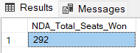

2.Seats Won by NDA Allianz Parties
SELECT
party as Party_Name,
won as Seats_Won
FROM
partywise_results
WHERE
party IN (
'Bharatiya Janata Party - BJP',
'Telugu Desam - TDP',
'Janata Dal (United) - JD(U)',
'Shiv Sena - SHS',
'AJSU Party - AJSUP',
'Apna Dal (Soneylal) - ADAL',
'Asom Gana Parishad - AGP',
'Hindustani Awam Morcha (Secular) - HAMS',
'Janasena Party - JnP',
'Janata Dal (Secular) - JD(S)',
'Lok Janshakti Party(Ram Vilas) - LJPRV',
'Nationalist Congress Party - NCP',
'Rashtriya Lok Dal - RLD',
'Sikkim Krantikari Morcha - SKM'
)
ORDER BY Seats_Won DESC
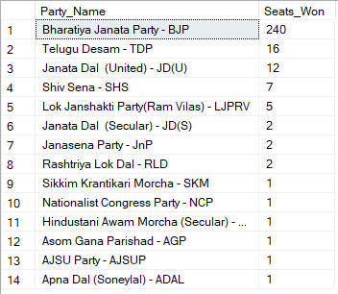
3.Total Seats Won by I.N.D.I.A. Allianz
SELECT
SUM(CASE
WHEN party IN (
'Indian National Congress - INC',
'Aam Aadmi Party - AAAP',
'All India Trinamool Congress - AITC',
'Bharat Adivasi Party - BHRTADVSIP',
'Communist Party of India (Marxist) - CPI(M)',
'Communist Party of India (Marxist-Leninist) (Liberation) - CPI(ML)(L)',
'Communist Party of India - CPI',
'Dravida Munnetra Kazhagam - DMK',
'Indian Union Muslim League - IUML',
'Nat`Jammu & Kashmir National Conference - JKN',
'Jharkhand Mukti Morcha - JMM',
'Jammu & Kashmir National Conference - JKN',
'Kerala Congress - KEC',
'Marumalarchi Dravida Munnetra Kazhagam - MDMK',
'Nationalist Congress Party Sharadchandra Pawar - NCPSP',
'Rashtriya Janata Dal - RJD',
'Rashtriya Loktantrik Party - RLTP',
'Revolutionary Socialist Party - RSP',
'Samajwadi Party - SP',
'Shiv Sena (Uddhav Balasaheb Thackrey) - SHSUBT',
'Viduthalai Chiruthaigal Katchi - VCK'
) THEN [Won]
ELSE 0
END) AS INDIA_Total_Seats_Won
FROM
partywise_results

4.Seats Won by I.N.D.I.A. Allianz Parties
SELECT
party as Party_Name,
won as Seats_Won
FROM
partywise_results
WHERE
party IN (
'Indian National Congress - INC',
'Aam Aadmi Party - AAAP',
'All India Trinamool Congress - AITC',
'Bharat Adivasi Party - BHRTADVSIP',
'Communist Party of India (Marxist) - CPI(M)',
'Communist Party of India (Marxist-Leninist) (Liberation) - CPI(ML)(L)',
'Communist Party of India - CPI',
'Dravida Munnetra Kazhagam - DMK',
'Indian Union Muslim League - IUML',
'Nat`Jammu & Kashmir National Conference - JKN',
'Jharkhand Mukti Morcha - JMM',
'Jammu & Kashmir National Conference - JKN',
'Kerala Congress - KEC',
'Marumalarchi Dravida Munnetra Kazhagam - MDMK',
'Nationalist Congress Party Sharadchandra Pawar - NCPSP',
'Rashtriya Janata Dal - RJD',
'Rashtriya Loktantrik Party - RLTP',
'Revolutionary Socialist Party - RSP',
'Samajwadi Party - SP',
'Shiv Sena (Uddhav Balasaheb Thackrey) - SHSUBT',
'Viduthalai Chiruthaigal Katchi - VCK'
)
ORDER BY Seats_Won DESC
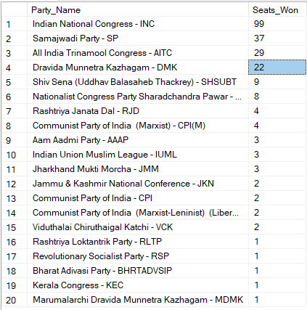
5.Add new column field in table partywise_results to get the Party Allianz as NDA, I.N.D.I.A and OTHER
ALTER TABLE partywise_results
ADD party_alliance VARCHAR(50);
I.N.D.I.A Allianz
UPDATE partywise_results
SET party_alliance = 'I.N.D.I.A'
WHERE party IN (
'Indian National Congress - INC',
'Aam Aadmi Party - AAAP',
'All India Trinamool Congress - AITC',
'Bharat Adivasi Party - BHRTADVSIP',
'Communist Party of India (Marxist) - CPI(M)',
'Communist Party of India (Marxist-Leninist) (Liberation) - CPI(ML)(L)',
'Communist Party of India - CPI',
'Dravida Munnetra Kazhagam - DMK',
'Indian Union Muslim League - IUML',
'Jammu & Kashmir National Conference - JKN',
'Jharkhand Mukti Morcha - JMM',
'Kerala Congress - KEC',
'Marumalarchi Dravida Munnetra Kazhagam - MDMK',
'Nationalist Congress Party Sharadchandra Pawar - NCPSP',
'Rashtriya Janata Dal - RJD',
'Rashtriya Loktantrik Party - RLTP',
'Revolutionary Socialist Party - RSP',
'Samajwadi Party - SP',
'Shiv Sena (Uddhav Balasaheb Thackrey) - SHSUBT',
'Viduthalai Chiruthaigal Katchi - VCK'
);
NDA Allianz
UPDATE partywise_results
SET party_alliance = 'NDA'
WHERE party IN (
'Bharatiya Janata Party - BJP',
'Telugu Desam - TDP',
'Janata Dal (United) - JD(U)',
'Shiv Sena - SHS',
'AJSU Party - AJSUP',
'Apna Dal (Soneylal) - ADAL',
'Asom Gana Parishad - AGP',
'Hindustani Awam Morcha (Secular) - HAMS',
'Janasena Party - JnP',
'Janata Dal (Secular) - JD(S)',
'Lok Janshakti Party(Ram Vilas) - LJPRV',
'Nationalist Congress Party - NCP',
'Rashtriya Lok Dal - RLD',
'Sikkim Krantikari Morcha - SKM'
);
OTHER
UPDATE partywise_results
SET party_alliance = 'OTHER'
WHERE party_alliance IS NULL;

6.Which party alliance (NDA, I.N.D.I.A, or OTHER) won the most seats across all states?
SELECT
p.party_alliance,
COUNT(cr.Constituency_ID) AS Seats_Won
FROM
constituencywise_results cr
JOIN
partywise_results p ON cr.Party_ID = p.Party_ID
WHERE
p.party_alliance IN ('NDA', 'I.N.D.I.A', 'OTHER')
GROUP BY
p.party_alliance
ORDER BY
Seats_Won DESC;

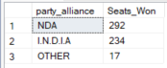

7.Winning candidate's name, their party name, total votes, and the margin of victory for a specific state and constituency?
SELECT cr.Winning_Candidate, p.Party, p.party_alliance, cr.Total_Votes, cr.Margin, cr.Constituency_Name, s.State
FROM constituencywise_results cr
JOIN partywise_results p ON cr.Party_ID = p.Party_ID
JOIN statewise_results sr ON cr.Parliament_Constituency = sr.Parliament_Constituency
JOIN states s ON sr.State_ID = s.State_ID
WHERE s.State = 'Uttar Pradesh' AND cr.Constituency_Name = 'AMETHI';
8.What is the distribution of EVM votes versus postal votes for candidates in a specific constituency?

SELECT
cd.Candidate,
cd.Party,
cd.EVM_Votes,
cd.Postal_Votes,
cd.Total_Votes,
cr.Constituency_Name
FROM
constituencywise_details cd
JOIN
constituencywise_results cr ON cd.Constituency_ID = cr.Constituency_ID
WHERE
cr.Constituency_Name = ‘MAHABUBNAGAR’
ORDER BY cd.Total_Votes DESC;
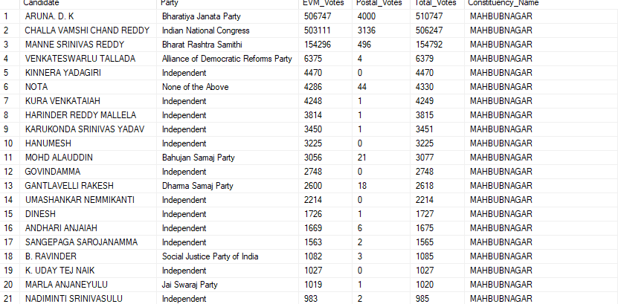

9.Which parties won the most seats in s State, and how many seats did each party win?
SELECT
p.Party,
COUNT(cr.Constituency_ID) AS Seats_Won
FROM
constituencywise_results cr
JOIN
partywise_results p ON cr.Party_ID = p.Party_ID
JOIN
statewise_results sr ON cr.Parliament_Constituency = sr.Parliament_Constituency
JOIN states s ON sr.State_ID = s.State_ID
WHERE
s.state = 'TELANGANA'
GROUP BY
p.Party
ORDER BY
Seats_Won DESC;
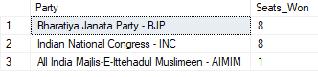

10.What is the total number of seats won by each party alliance (NDA, I.N.D.I.A, and OTHER) in each state for the India Elections 2024
SELECT
s.State AS State_Name,
SUM(CASE WHEN p.party_alliance = 'NDA' THEN 1 ELSE 0 END) AS NDA_Seats_Won,
SUM(CASE WHEN p.party_alliance = 'I.N.D.I.A' THEN 1 ELSE 0 END) AS INDIA_Seats_Won,
SUM(CASE WHEN p.party_alliance = 'OTHER' THEN 1 ELSE 0 END) AS OTHER_Seats_Won
FROM
constituencywise_results cr
JOIN
partywise_results p ON cr.Party_ID = p.Party_ID
JOIN
statewise_results sr ON cr.Parliament_Constituency = sr.Parliament_Constituency
JOIN
states s ON sr.State_ID = s.State_ID
WHERE
p.party_alliance IN ('NDA', 'I.N.D.I.A', 'OTHER') -- Filter for NDA and INDIA alliances
GROUP BY
s.State
ORDER BY
s.State;

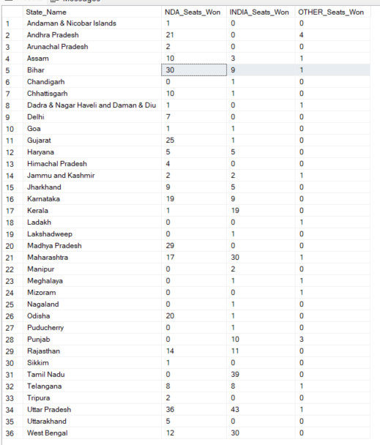

11.Which candidate received the highest number of EVM votes in each constituency (Top 10)?
SELECT TOP 10
cr.Constituency_Name,
cd.Constituency_ID,
cd.Candidate,
cd.EVM_Votes
FROM
constituencywise_details cd
JOIN
constituencywise_results cr ON cd.Constituency_ID = cr.Constituency_ID
WHERE
cd.EVM_Votes = (
SELECT MAX(cd1.EVM_Votes)
FROM constituencywise_details cd1
WHERE cd1.Constituency_ID = cd.Constituency_ID
)
ORDER BY
cd.EVM_Votes DESC;

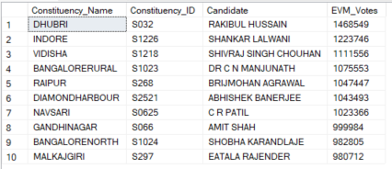

12.Which candidate won and which candidate was the runner-up in each constituency of State for the 2024 elections?
WITH RankedCandidates AS (
SELECT
cd.Constituency_ID,
cd.Candidate,
cd.Party,
cd.EVM_Votes,
cd.Postal_Votes,
cd.EVM_Votes + cd.Postal_Votes AS Total_Votes,
ROW_NUMBER() OVER (PARTITION BY cd.Constituency_ID ORDER BY cd.EVM_Votes + cd.Postal_Votes DESC) AS VoteRank
FROM
constituencywise_details cd
JOIN
constituencywise_results cr ON cd.Constituency_ID = cr.Constituency_ID
JOIN
statewise_results sr ON cr.Parliament_Constituency = sr.Parliament_Constituency
JOIN
states s ON sr.State_ID = s.State_ID
WHERE
s.State = ‘TELANGANA’
)

SELECT
cr.Constituency_Name,
MAX(CASE WHEN rc.VoteRank = 1 THEN rc.Candidate END) AS Winning_Candidate,
MAX(CASE WHEN rc.VoteRank = 2 THEN rc.Candidate END) AS Runnerup_Candidate
FROM
RankedCandidates rc
JOIN
constituencywise_results cr ON rc.Constituency_ID = cr.Constituency_ID
GROUP BY
cr.Constituency_Name
ORDER BY
cr.Constituency_Name;
